Structural FEM Code Verification

Cantilever Beam Bending

Case: A uniform cross section beam of length L with Young’s Modulus E and Moment of Inertia around bending axis I under applied uniform distributed load, w. What is the maximum deflection at the tip of the beam?

w = 1 N/m

L = 1 m

E = 70 MPa

I = 5.207x10-7 m4

x

y

Analytical Solution

From Shigley’s Beam Tables, $y_{max}=\frac{-wL^{4}}{8EI}$

Numerical Solution

The model consists of 50x5x5 hexahedral elements with a total dimension of 1mx0.05mx0.05m. Nodal loads are distributed and applied on the top surface. The fixed end are applied a boundary condition of displacements = 0 in x, y and z.

The code assembles the stiffness matrix by integration of order 2. [K]{U}={F} is solved using direct matrix inversion.

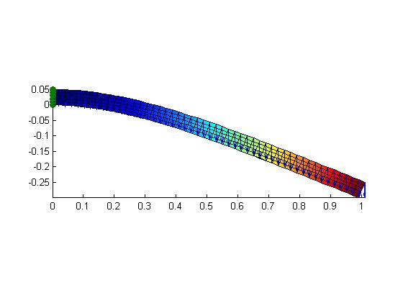

|  |  |  |
| --- | --- | --- |
|  | Theory | Code |
| Displacement | 3.428mm | 3.215mm |
| Percent Error | 0% | 6.2% |